**61-Introduction to One-Dimensional Array:**

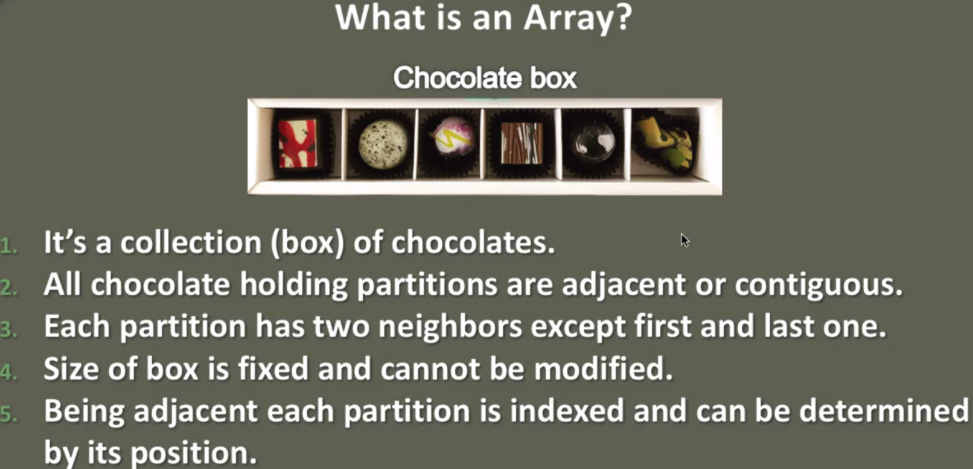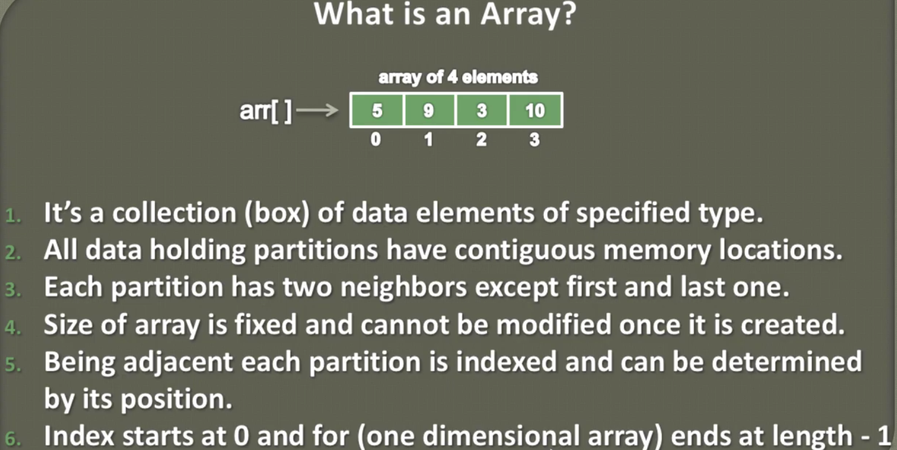

**62-Declaration and Initialization of a One-Dimensional Array**

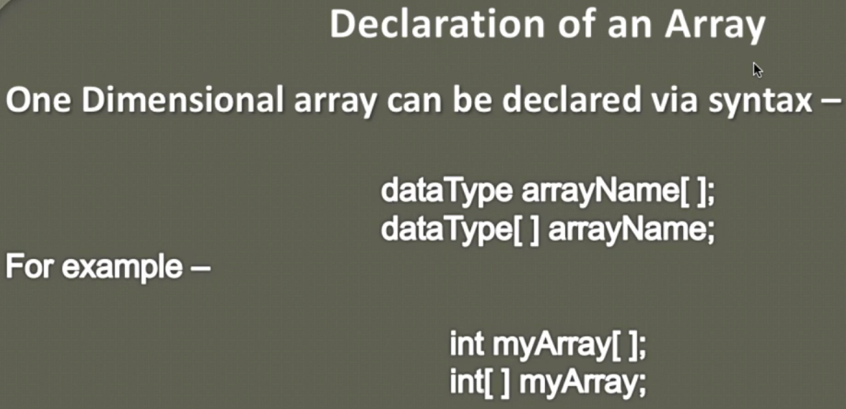

**Second one is mostly used because from the beginning we can identify from [] that it is an array of int type.**

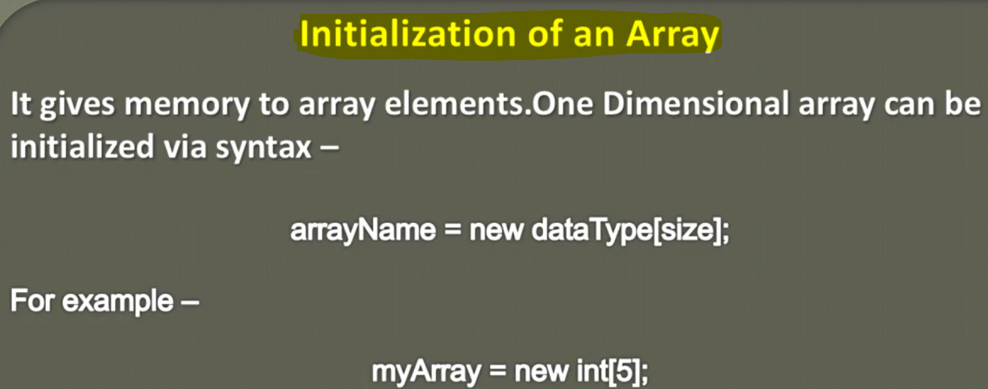

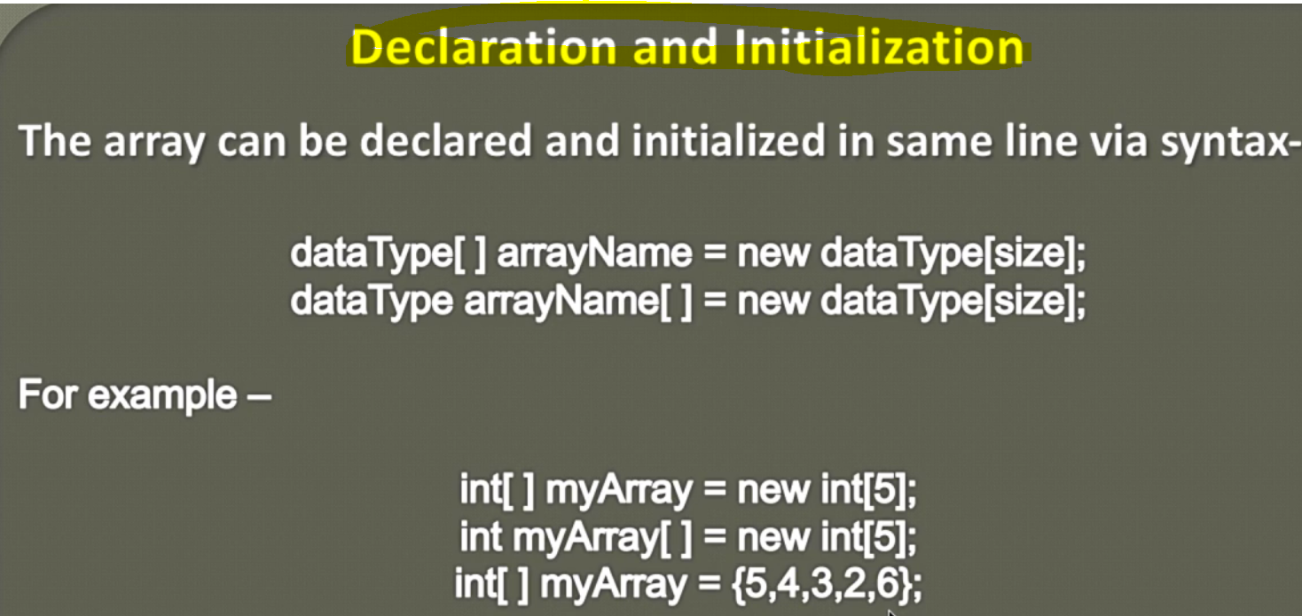

**63-Adding or Updating elements in a One-Dimensional Array _ Animation**

**64-Adding or Updating elements in a One-Dimensional Array _ Implementation**

**65-How to print elements of an Array in Java_ _ Animation**

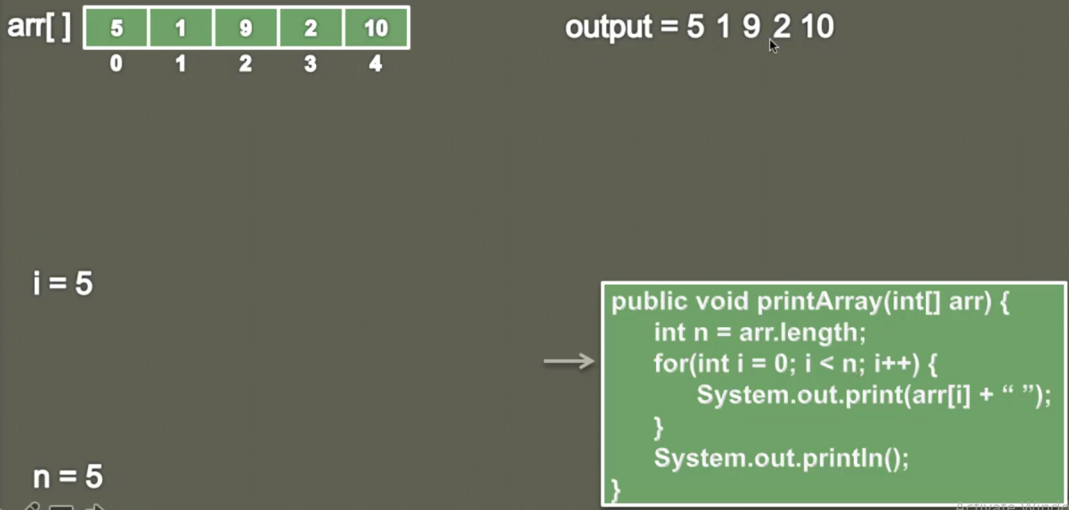

**66-How to print elements of an Array in Java_ _ Implementation**

**Program;**

**67-How to reverse an array in Java –Animation**

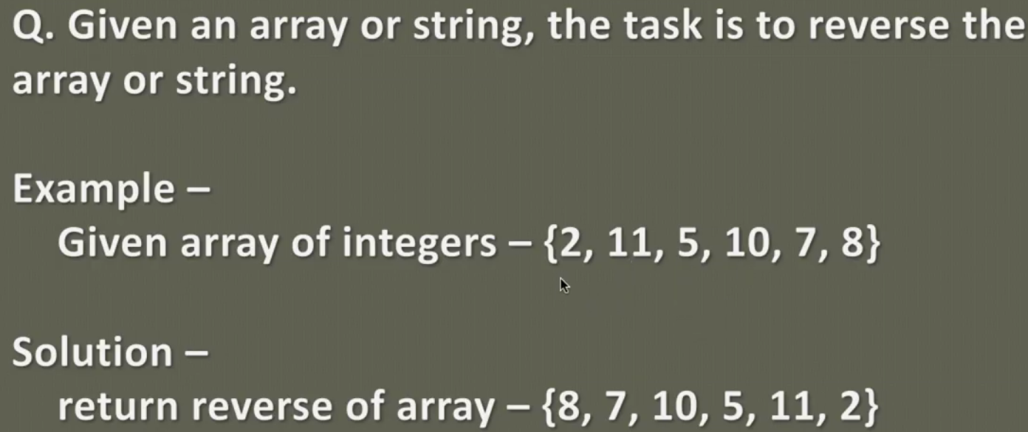

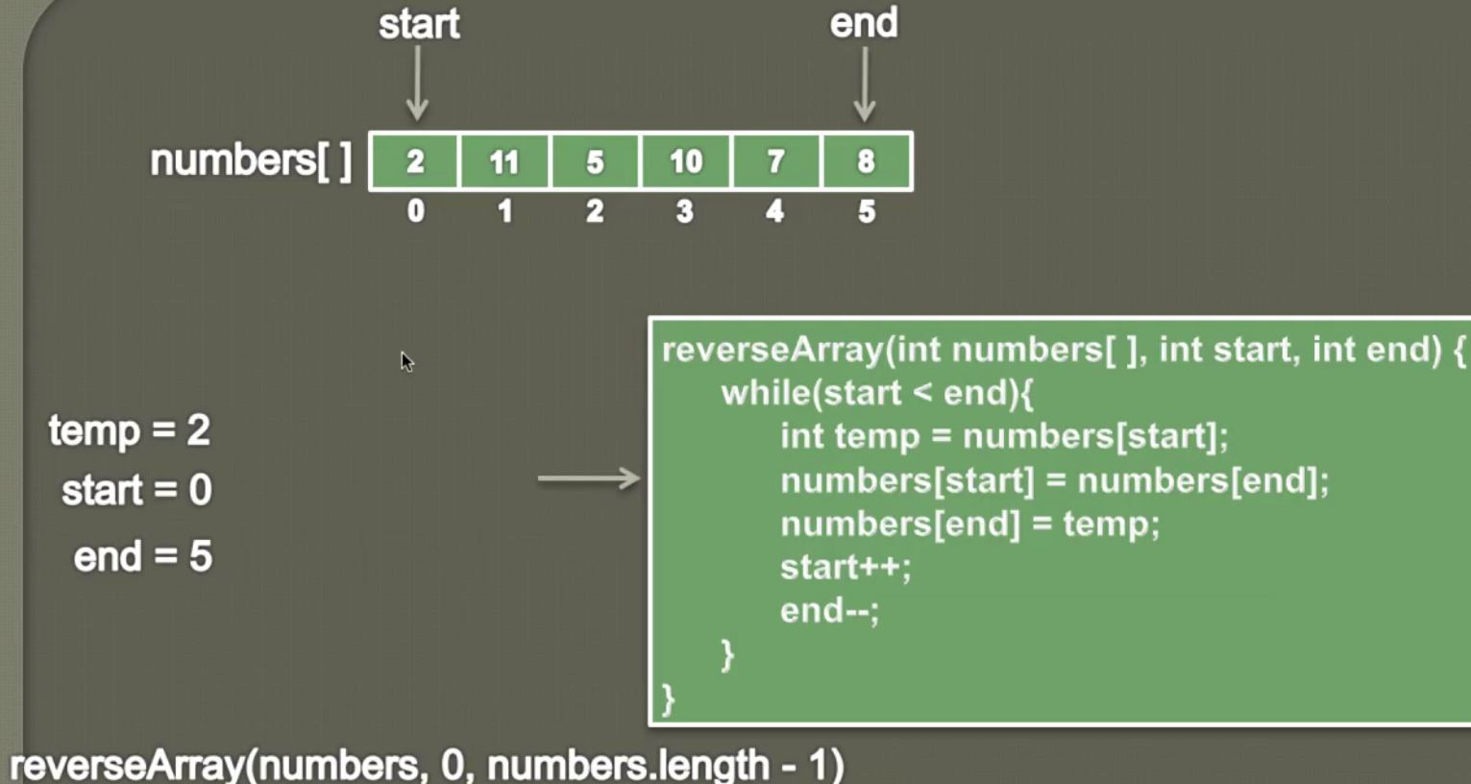

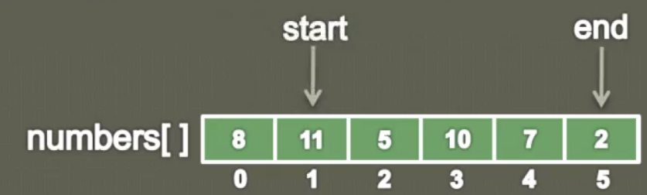

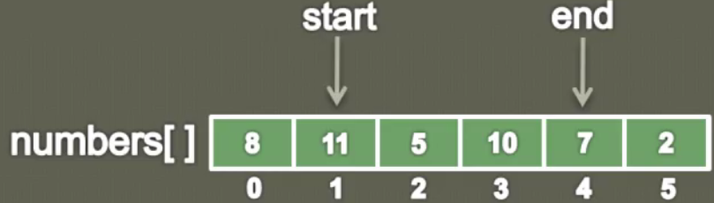

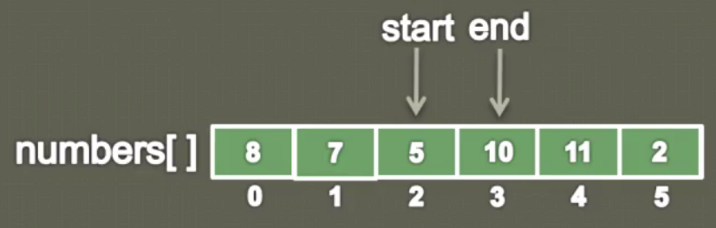

Concept:

1. Create two pointer startIndex and endIndex
2. Initialize startIndex with 0, so that we could traverse from the first element of an array
3. Initialize endIndex with [arr.length-1] i.e. last index of the array element so that we can swap first element with last element to reverse array
4. Now check condition while startIndex < endIndex till then keep swapping arr[startIndex] with arr[endIndex] using third variable temp

|  |
| --- |
| **public** **void** reverseArray(**int**[] arr, **int** startIndex, **int** endIndex) {  **while**(startIndex < endIndex) {  // {2,11,5,10,7,8}    // Create a temp variable and store arr[startIndex]  **int** temp = arr[startIndex];  // Swap StartIndex value with endIndex value  arr[startIndex]= arr[endIndex];  // and then at the last index store the temp value having startIndex values  arr[endIndex]= temp;  // Increase startIndex by 1 so that it could reach towards end of array  // decrease endIndex by1 so that it could reach towards start of array  startIndex++;  endIndex--;  }  } |

**Full Program:**

|  |
| --- |
| **package** com.data.structure.arrays;  **public** **class** B_ReverseArray_2 {  // Method to print array  **public** **void** printArray(**int**[] arr) {  **for**(**int** i= 0; i<arr.length; i++) {  System.***out***.print(arr[i] +" ");  }  }  // Method to reverse array  **public** **static** **void** main(String[] args) {  B_ReverseArray_2 revArr= **new** B_ReverseArray_2();    **int**[] array = **new** **int**[] {1,2,3,4,5,6};  System.***out***.println("Original sequence");  revArr.printArray(array);  System.***out***.println();  **int**[] revers = revArr.revers(array);  System.***out***.println("reverse sequence");  revArr.printArray(revers);  }  // main method  **public** **static** **void** main(String[] args) {  B_ReverseArray_2 revArr= **new** B_ReverseArray_2();    **int**[] array = **new** **int**[] {1,2,3,4,5,6};  revArr.printArray(array);  System.***out***.println();  **int**[] revers = revArr.revers(array);  revArr.printArray(revers);  }  } |
| Output:  Original sequence  1 2 3 4 5 6  reverse sequence  6 5 4 3 2 1 |

**69-How to find Minimum value in an Array – Animation**

**.**

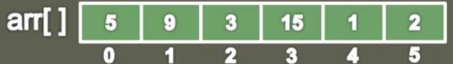

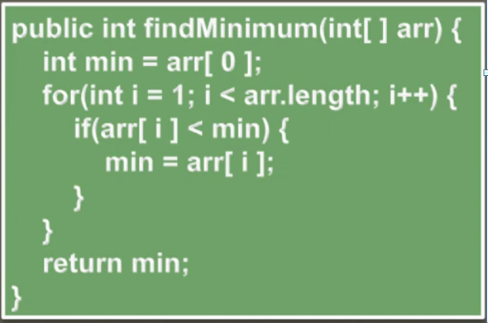

|  |
| --- |
| **public** **int** findMinValueOfArray(**int**[] arr) {    // Create one int variable min and store the first index value in the min  **int** min = arr[0];  // Now in the for loop compare this min value with each index value and if index value is < than min then store that index value into min variable untill indexedValue < min of array  **for**(**int** i=0; i< arr.length; i++) {  **if**(arr[i] < min) {  min = arr[i];  }  }  **return** min;  } |

Idea and full program to write:

**Find max element of array:**

|  |
| --- |
| Idea and logic to be mentioned: |
| **public** **int** findMAXValueOfArray(**int**[] arr) {  // Create one int variable min and store the first index value in the min  **int** max = arr[0];  // Now in the for loop compare this min value with each index value and and if  // index value is < than min then store that index value into min variable  // untill indexedValue < min of array  **for** (**int** i = 0; i < arr.length; i++) {  **if** (arr[i] > max) {  max = arr[i];  }  }  **return** max;  } |

Full Program to be mentioned:

**71-How to move Zeroes to end of an Array_ _ Animation**

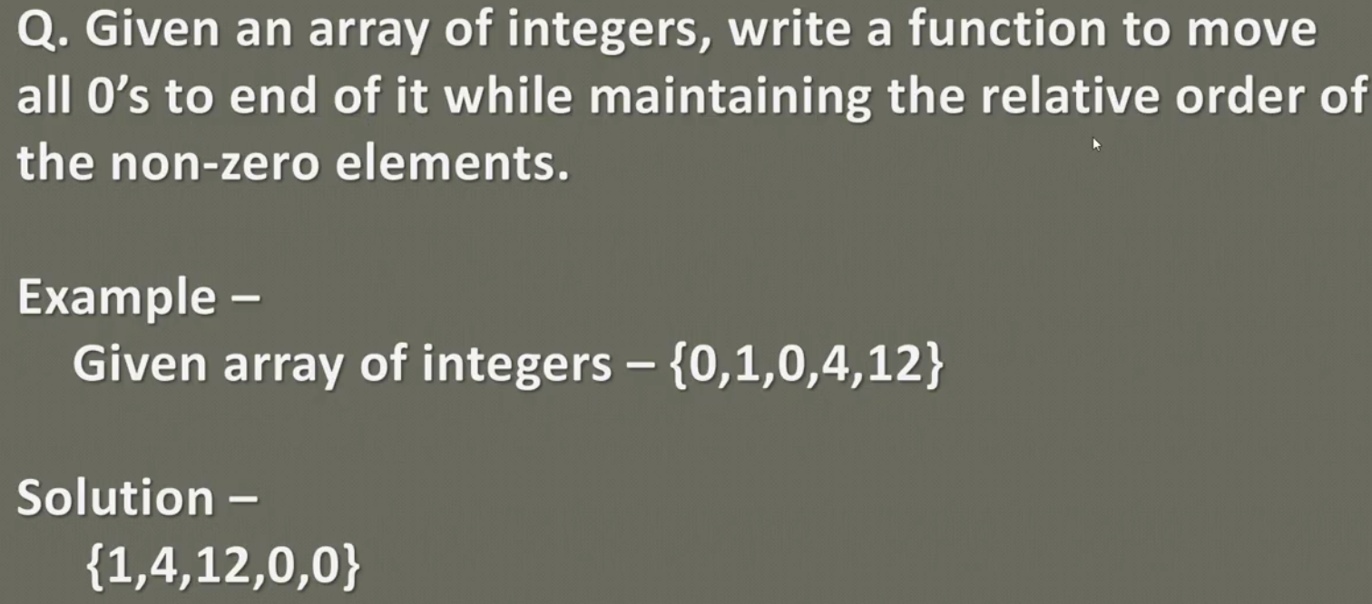

**Let’s we have one array as given bleow and we have to move all zeros to end of array.**

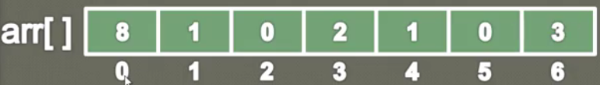

**Let’s do this using below algo:**

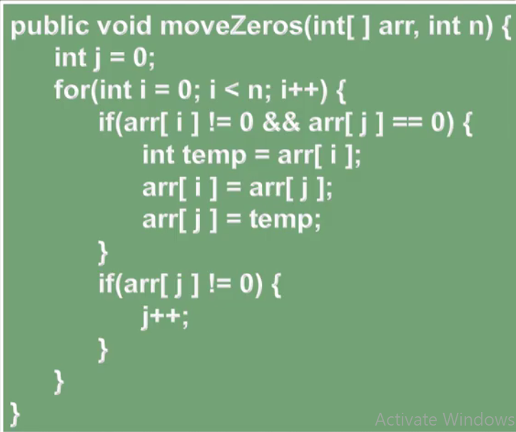

The idea behind this algo is listed below.

1. First will create method with having two arguments [int[] array, int n(array length)]
2. We will take two pointers Int i (inside for loop) & int j. Here one pointer i will focus on non-zero elements, and other pointer will focus on zero elements. And when one of pointer point to non-zero element and another pointer zero element then we will perform swapping for each other.
3. So basically we will use swapping to swap non-zero with zero element for the entire element of array, and for that we have to traverse from index 1 to end of the array in the for loop
4. As we can see that, inside for loop, in first if condition if pointer (i) points to non-zero and pointer (j) points to zero element using a third variable temp we perform swapping between each-other.

|  |
| --- |
| If(arr[i] ! = 0 && arr[j] ==0){ // i.e. if i points non-zero and j points to zeroth element then  int temp = arr[i];  arr[i] = arr[j];  arr[j] = temp;  } |

1. And we keep moving pointer j just by incrementing one if pointer j does not points to non-zero element.

|  |
| --- |
| If(arr[j] !=0){  J++;  } |

Program:

|  |
| --- |
| **package** com.data.structure.arrays;  **public** **class** D_MoveAllZeroElementToArrayEnd_4 {  **public** **static** **void** printArray(**int**[] arr) {  **for**(**int** i=0;i< arr.length; i++) {  System.***out***.print(arr[i] + " ");  }  }  // Method to create Array  **public** **static** **void** ArrayDemo(){  // Declare Array Type and its size  **int**[] array = {1,0,2,0,3,4,0,5};  **int** n = array.length;  System.***out***.println("Original Array---");  *printArray*(array);  System.***out***.println();  *moveZeroElementArrayToEnd*(array, n);  System.***out***.println("After moving all zero to end of Array");  *printArray*(array);  }  **public** **static** **void** main(String[] args) {  *ArrayDemo*();  }  **// Method to move all zero to end of array.**  **public static void moveZeroElementArrayToEnd(int[] array, int length) {**    **int j=0; // For pointing zero elements of the array**  **for(int i=0; i<length; i++) {**  **if(array[i]!=0 && array[j]==0) {**  **// Check if i points to non-zero ele & j point to zeroth ele**  **// Start Swapping both the i and j pointing element using third variable.**  **int temp = array[i];**  **array[i]=array[j];**  **array[j]=temp;**  **}**  **if(array[j]!=0) {**  **// For entire array element if when j does not points to zeroth elment then keep moving j by increasing 1**  **j++;**  **}**  **}**  **}**  } |
| **Output:**  Original Array---  1 0 2 0 3 4 0 5  After moving all zero to end of Array  1 2 3 4 5 0 0 0 |

**73-How to resize an Array in Java – Animation**

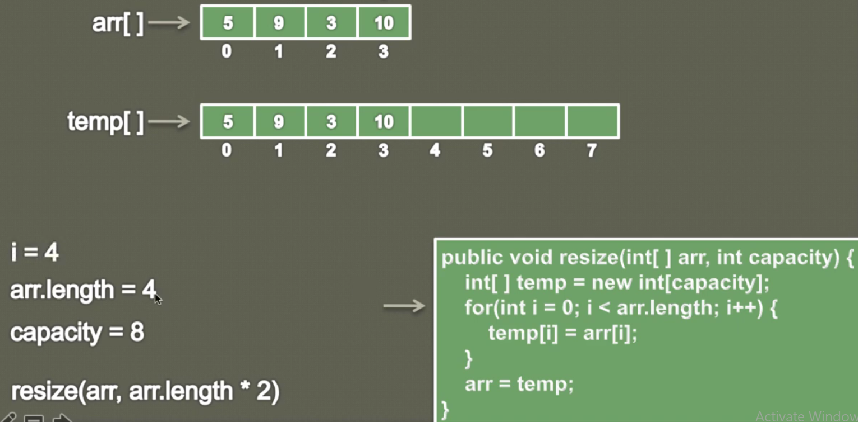

As we know that once declare the size of array then we cannot increase or decrease the size of array. But we can re-size an array. For example when we create an ArrayList then inside an ArrayList an array gets created of default size and we add elements to that default size then it gets stored in the internal array and as soon as we try to add more elements so internally a new temporary array is created with size more than that of original array and then all the original array element are copied from original array to this temporary array and finally the original array points to this temporary array.

So same thing we have done in the above array.

1. Let’s say we have an original arr[] with the original size=4
2. Now we have to increase the size of this array from 4 to 8
3. Let’s create a method resize(int[] arr, int newCapacity)
4. Now inside the method create a temporary array with the newCapacity
5. And then using the for loop will copy all the original array element in the temporary array
6. And once all the elements get copied the assign this temp array to original array arr.

Program :

|  |
| --- |
| **package** com.data.structure.arrays;  **public** **class** E_ResizeOriginalArray_5 {    **public** **void** printArray(**int**[] arr) {  **for**(**int** i=0;i< arr.length; i++) {  System.***out***.print(arr[i] + " ");  }  }  **public int[] resize(int[] arr, int newCapacity) {**  **int[] temp = new int[newCapacity];**  **for(int i=0; i< arr.length; i++) {**  **temp[i]= arr[i];**  **}**  **arr=temp;**  **return arr;**  **}**  **public** **static** **void** main(String[] args) {  E_ResizeOriginalArray_5 arrUtil = **new** E_ResizeOriginalArray_5();  // Declare Array Type and its size  **int**[] array = {1,2,3,4};  **int** n = array.length;  System.***out***.println("Original array size is-"+array.length);  arrUtil.printArray(array);  System.***out***.println();  array= arrUtil.resize(array, 8);  **int** n1 = array.length;  System.***out***.println("After increasing size-"+n1);  arrUtil.printArray(array);  }  } |
| **Output:**  Original array size is-4  1 2 3 4  After increasing size-8  1 2 3 4 0 0 0 0 |

**75-How to merge two sorted arrays in Java_ _ Animation _ Part 1**

Let’s say we have two sorted array as given below.

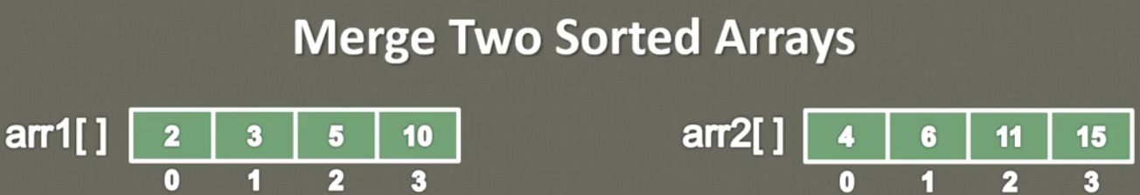

So we have to merge in such a way that the resultant array also should be sorted. So we will do the following things.

1. Create a resultant array whose length is equal to the sum of arr1 and arr2

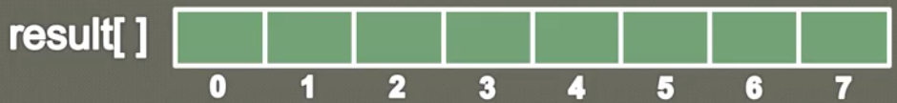

1. Since both the arrays arr1 & arr2 are already sorted array so we will just compare both the array’s element one by one and whichever is smaller we simply put it into the result array.
2. So to perform above activity we will take three pointers, one pointer will start from arr1, another pointer will start from arr2 and the third pointer will start from result array. Then we start comparing arr1 and arr2 elements using their respective index and whichever is smaller will put it into result array.

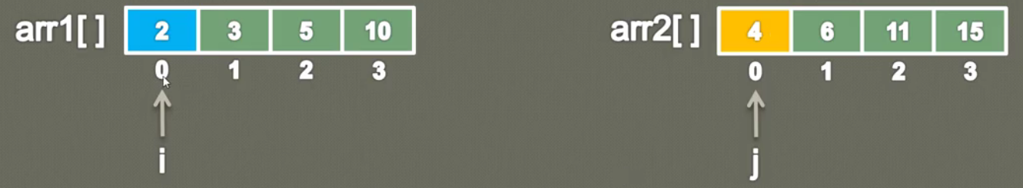 So in the first step we will compare first index of both the arrays and we can see that first index of arr1 is smaller that first index of arr2 so we just put arr1 into result array as shown below.

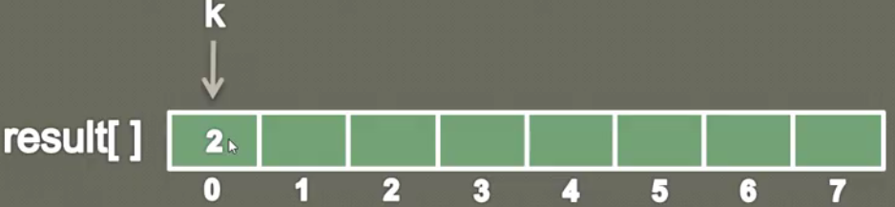

Now once we filled arr1 first value then we will increase i by one and since result array first position also got filled so we will increase k by 1 and now again we compare arr1 i’th index with arr1 j’th index.

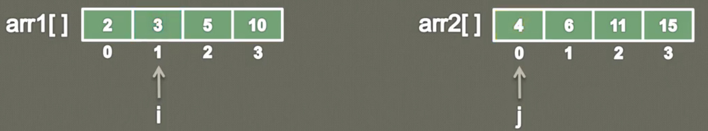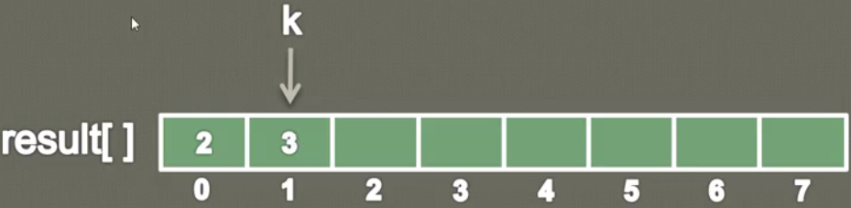

As we after compare we can see arr1 i’th index value is less than arr2 j’th index so we just simply put arr1 i’th index value into result array.

Since current i’th position or arr1 has been used so we will increase i by one and since we filled k’th current position also so we will increase k by one.

Now repeat the above steps

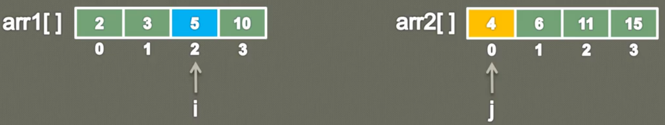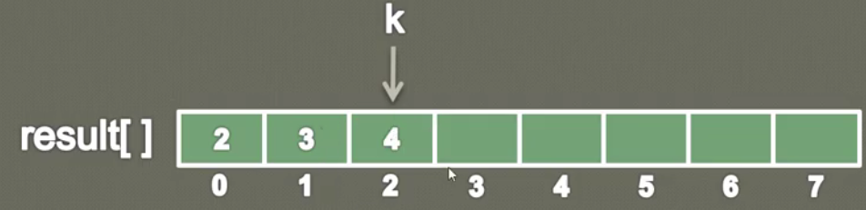

Now we can see that arr2 j’th index is less than arr1 current i’th position so we put arr2 j’th index value into result array. Now here we have used arr2 j’th current index so now we will increase j’th current position by one and similarly increase k also by one to fill the next value.

So in general we can say that wherever we are finding any lowest value in arr1 or arr2, we are simply increment that pointer and we don’t increase other array pointer because that value still needs to be filled inside the result array.

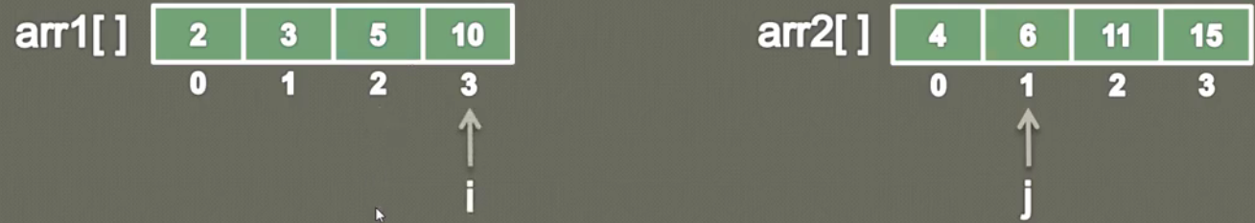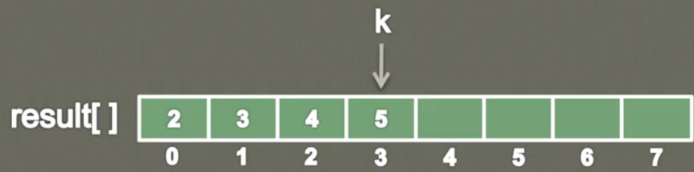

Next Step:

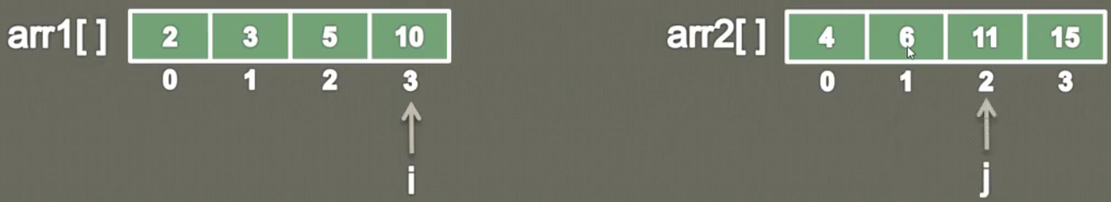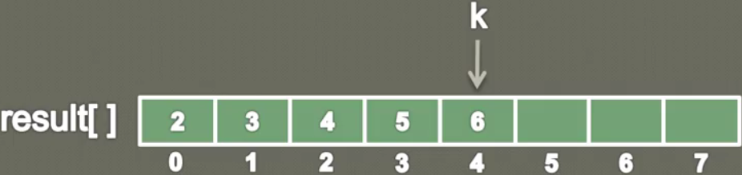

Next Step:

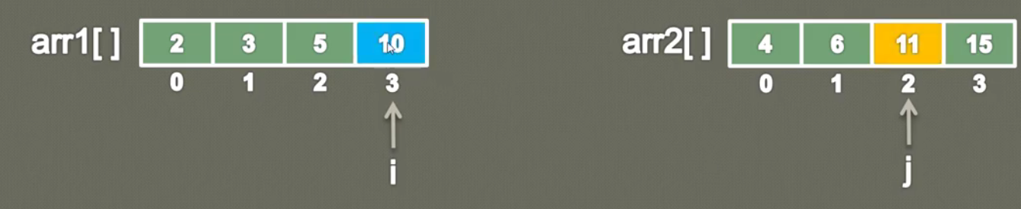

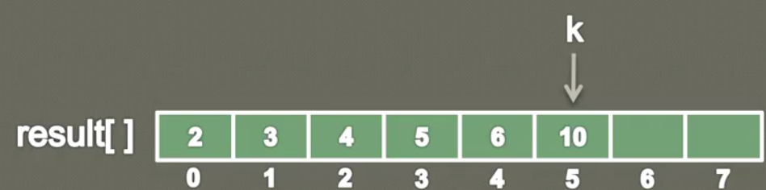

So now on the k’th position 10 will update. And now we can see that there is no position left in arr1 to be compared with arr2, so it means all the value of arr1 are filled in the result array and we are left with element of arr2 which are already sorted, so now our task is just put arr2 remaining values into result array because we don’t have to compare it with any other values.

So we just keep increasing j and k and keep coping arr2 element in result array till both reach towards end. So finally we will get the result array as given below.



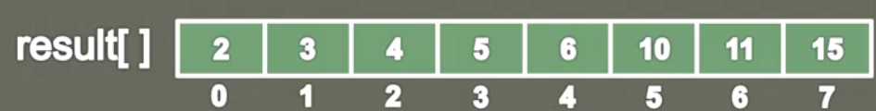

So this is the idea how to merge two sorted array. So by using three pointer i , j , k.

Arr1 is traversed by pointer i, j is used to traverse arr2 and k is used to traverse result array. And compare the arr1 and arr2 I’th and j’th index value and whichever is smaller will put into result k’th index and whichever value it took either from arr1 or arr2, will simply increment that respective pointer and as we are filling up with result array so we will also increment k’th pointer.

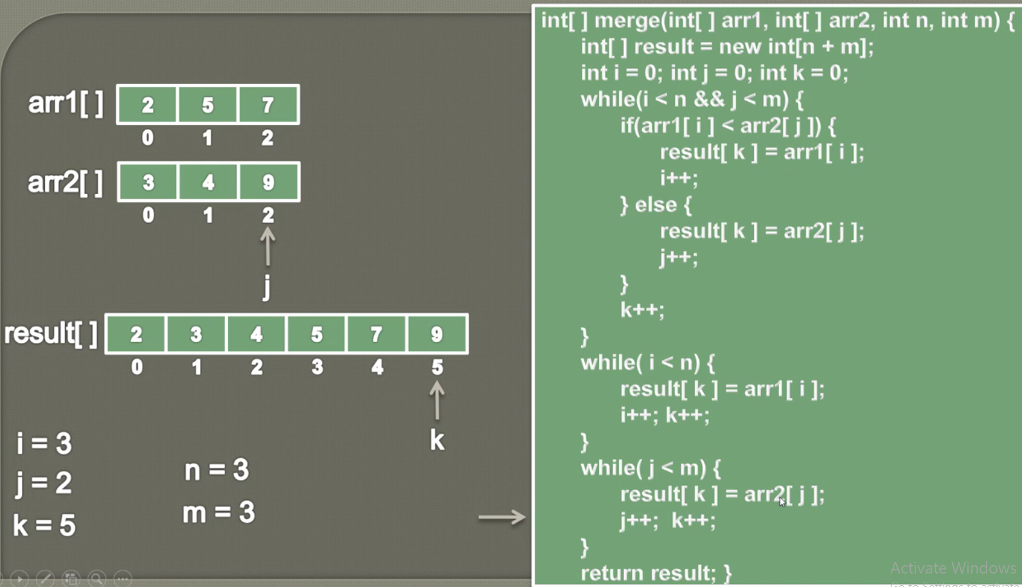

Note1-: The first while is being used when I & j both is less than the size of arr1 and arr2 length.

Note2-: The second while will be used when arr2 completely filled their value in the result array and j becomes greater than arr2 length.

Note3-: The third while will be used when arr2 completely filled their value in the result array and I become greater than size of arr1

|  |
| --- |
| **package** com.data.structure.arrays;  **public** **class** F_MergeTwoSortedArray_6 {    // Method to print array  **public** **void** printArray() {    }  // Method to merge two sorted array  **public** **int**[] merge(**int**[] arr1, **int** arr2, **int** length1, **int** length2) {  // Create three pointer i, j, k for arr1 , arr2 & result array  // Create a result[] with the size equal to arr1+arr2 size  // First while loop when i and j is less than the size of arr1 && arr2  // either arr1 got exhausted or arr2 got exhausted  // Second while if arr2 got exhausted then all the value of arr1 will be copied into result array  // Third while if arr1 got exhausted then all the values of arr2 will be copied into result array  // Finally return the result array    **int**[] result = **null**;  **return** result;  }  // Main method  **public** **static** **void** main(String[] args) {  // Create sorted arr1 and arr2  // First call the printArray() method to print both the arrays  // Now call the merge **method (arr1, arr2, length1, length);** and store this into array variable result.  // call the print method to print result array.  }  } |

Full Program:

|  |
| --- |
| **package** com.data.structure.arrays;  **public** **class** F_MergeTwoSortedArray_6 {    // Method to print array  **public** **static** **void** printArray(**int**[] arr) {  **for**(**int** i=0;i< arr.length; i++) {  System.***out***.print(arr[i] + " ");  }  }  // Method to merge two sorted array  **public** **int**[] merge(**int**[] arr1, **int**[] arr2, **int** length1, **int** length2) {  // Create three pointer i, j, k for arr1 , arr2 & result array  // Create a result[] with the size equal to arr1+arr2 size  // First while loop to traverse both the arrays until i and j is less than the size of arr1 && arr2  // either arr1 got exhausted or arr2 got exhausted  // Second while if arr2 got exhausted then all the value of arr1 will be copied into result array  // Third while if arr1 got exhausted then all the values of arr2 will be copied into result array  // Finally retrun the result array  **int** i=0;  **int** j=0;  **int** k=0;    **int**[] result = **new** **int**[length1+length2];  **while**(i< length1 && j < length2) // Traverse both the arrays until i and j is less than the size of arr1 & arr2  {  **if**(arr1[i] < arr2[j]) {  // Now compare both the arrays using index pointer i and j and if arr1 value is smaller than arr2 then put this arr1 value into result array  result[k] = arr1[i];  // Now increase arr1 by one so that next element can be compared and increase k by one so that next value can be copied from arr1 or arr2  i++;  }// Now in else part if arr2 element is smaller than arr1 element then put arr2 element in result array and increase j and k by one  **else** {  result[k] = arr2[j];  j++;  }// Finally increase position by one so that next value either from arr1 or arr2 could be inserted  k++;  }// Now if any one of the two array [arr1 or arr2] element is copied then traverse the array which still have elements to be copied into result array    **while**(i<length1) {// Let's say arr2 completely copied then we will traverse arr1  result[k] = arr1[i];  i++; k++;  }  **while**(j<length2) {// Let's say arr1 completely copied then we will traverse arr2  result[k] = arr2[j];  j++; k++;  }  **return** result;  }  // Main method  **public** **static** **void** main(String[] args) {  F_MergeTwoSortedArray_6 merge2Array= **new** F_MergeTwoSortedArray_6();  // Create sorted arr1 and arr2  // First call the printArray() method to print both the arrays  // Now call the merge method(arr1, arr2, length1, length); and store this into array variable result.  // call the print method to print result array.  **int**[] array1= **new** **int**[] {2,5,8,10};  System.***out***.println("Array-1::");  *printArray*(array1);  System.***out***.println();  **int**[] array2= **new** **int**[] {3,4,9,11};  System.***out***.println("Array-2::");  *printArray*(array2);  System.***out***.println();  **int**[] merge = merge2Array.merge(array1, array2, array1.length, array2.length);  System.***out***.println("Merged Array::");  *printArray*(merge);    }  } |

**78-How to check if a given String is a Palindrome - String Algorithm**

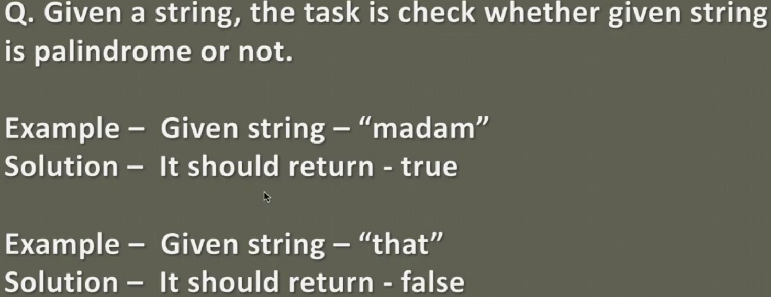

**Algo:**

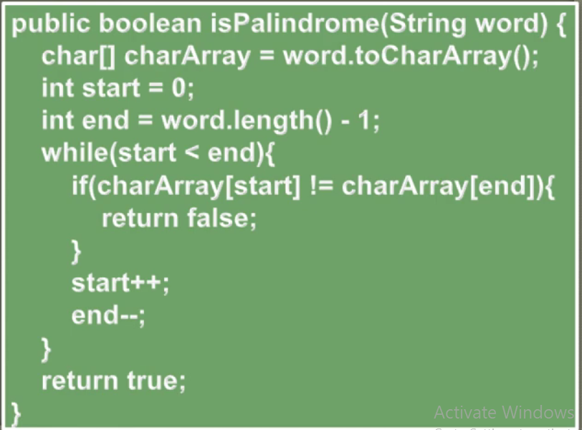

**Concept:**

1. Convert the given string into charArray using toCharArray() method of String.
2. Create two pointer int start =0 and int end = charArray.length-1,
3. Now traverse the whole charArray and check first and last character , then second and second last and so on until start < end and if both are equal then return true else return false
4. And increase start by one so that after comparing one char we it could move forward and similarly decrease end by one so that it could backward by one char

|  |
| --- |
| **package** com.data.structure.arrays;  **public** **class** G_CheckPalindrom_7 {  // Method to print array  **public** **static** **void** printArray(**char**[] charArray) {  **for**(**int** i=0;i< charArray.length; i++) {  System.***out***.print(charArray[i] + " ");  }  }  **public** **boolean** checkPalndrom(String name) {  **char**[] charArray = name.toCharArray();  **int** start=0;  **int** end = charArray.length-1;  **for**(**int** i=0; i<charArray.length; i++) {  **if**(charArray[start]==charArray[end]) {  **return** **true**;  }  start++; end--;  }  **return** **false**;  }  **public** **static** **void** main(String[] args) {  G_CheckPalindrom_7 check= **new** G_CheckPalindrom_7();  String name= "Madam1";  System.***out***.println("Givne String::"+ name);  **boolean** checkPalndrom = check.checkPalndrom(name);  **if**(checkPalndrom==**true**) {  System.***out***.println("It is palindrom");  }**else**  System.***out***.println("It is not palindrom");  }  } |
| **Output:**  Givne String::Madam  It is palindrom  Givne String::Madam1  It is not palindrom |

**115-Linear Search in Java _ Searching Algorithm _ Animation**

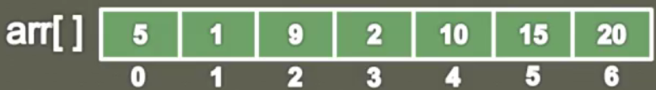

Let’s say we have given an array and we have to find an element from the given array using the below algo:

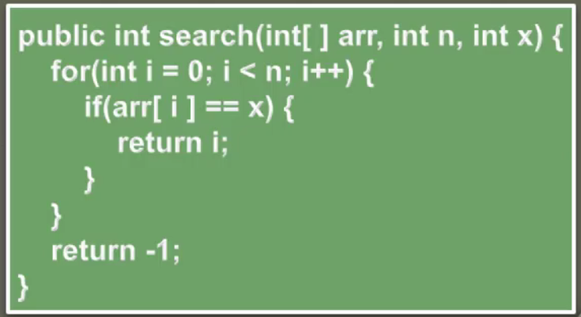

**Concept:**

1. So we will create a method search of return type integer and we will pass the arr [] from the number has to search and the number which has to be search in the array.
2. So the idea behind this algo is that we will traverse the entire array element using for loop and inside for loop in the if condition we will compare each element with the “to be searched element”
3. If (arr[i] == x) i.e. if element matched then just return the index at which it is found else return -1

Program:

|  |  |
| --- | --- |
| **package** com.data.structure.arrays;  **public** **class** I_LinearSearch_8 {  // Method to print array  **public** **static** **void** printArray(**int**[] array) {  **for**(**int** i=0;i< array.length; i++) {  System.***out***.print(array[i] + " ");  }  }  // Method to search element using Linear Search  **public** **int** search(**int**[] array, **int** x) {  // Traverse the array element  **for**(**int** i=0; i<array.length; i++) {  **if**(array[i]==x) {  **return** i;  }  }  **return** -1;  }  // Main method  **public** **static** **void** main(String[] args) {  I_LinearSearch_8 linear = **new** I_LinearSearch_8();  **int**[] array = **new** **int**[] {1,2,3,4,5,6,7,8};  **int** searchElement= 5;  *printArray*(array);  System.***out***.println();  **int** searchIndex = linear.search(array, searchElement);  System.***out***.println(searchElement +" is found at "+searchIndex);  }  } | |
| **Output:** 1 2 3 4 5 6 7 8  5 is found at 4 | 1 2 3 4 5 6 7 8  15 is found at -1 |

**117-Binary Search in Java**

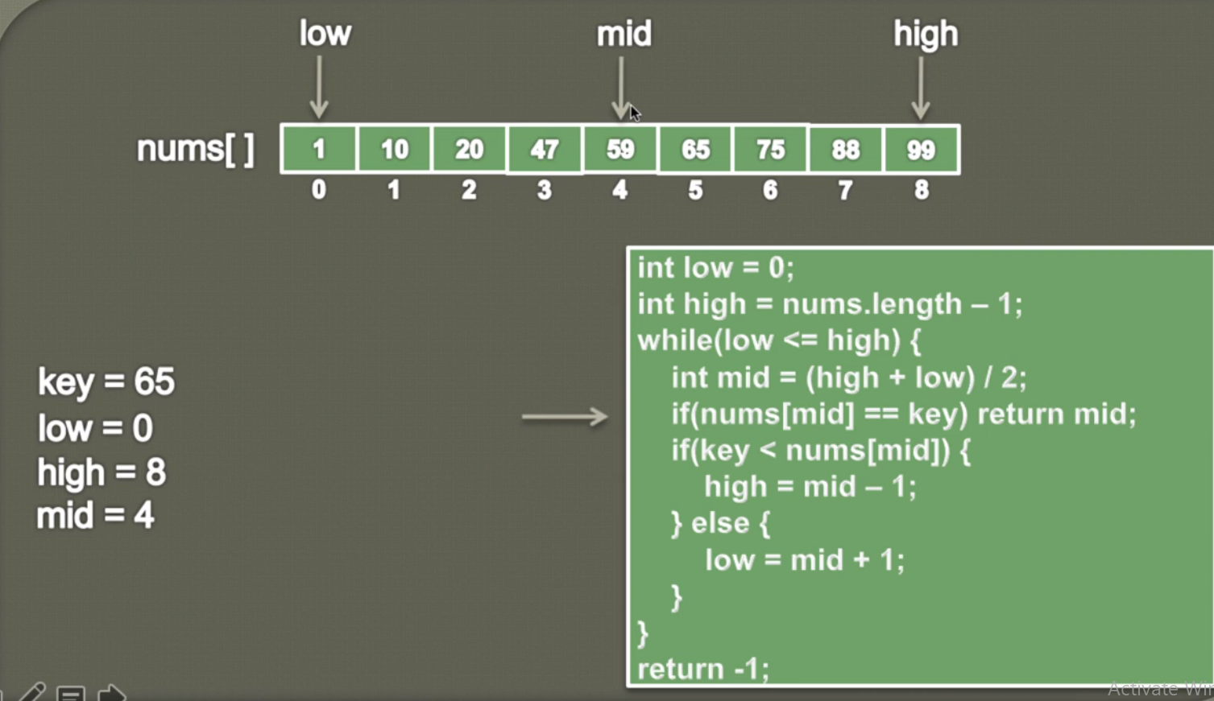

Concept:

So the idea behind this concept is that, binary search can be applied only on sorted array. And instead of searching the key in entire array, searching always will be done in the half of the array, in this way it will take less time to traverse and hence the performance will improve.

So to search in the half part of the array we will follow the above algo.

1. Created two pointer [startIndex or lowIndex=0] and [endIndex or highIndex= array.lenght-1] i.e. traverse from first index to last index of the array
2. Now in the while until lowIndex(or startIndex) is < = highIndex(or endIndex), will keep calculating mid of array using int mid = (high+low)/ 2
3. Now check if min index value is matched with the searchKey then return the same mid index, otherwise we will have to search either in the first half or last half of the mid index.
4. So now we will check if searchKey is < than mid index value then searchKey will be available in the first half and if searchKey > mid index value then search Key will be available in the last part of the array.
5. Now if search key is available in the first half then to search key, we will have to traverse from first index to one index before of the mid index and then in this case we will have to shift highIndex (or endIndex) in the first half of the array, so that we could have a range to traverse between start and end point of the first half of the array. So to shift highIndex(or endIndex) :=> highIndex = midIndex -1;
6. Now if search key is available in the last half then to search key, we will have to traverse from first index to one index after of the mid index and then in this case we will have to shift lowIndex (or startIndex) in the last half of the array, so that we could have a range to traverse between start and end point of the last half of the array. So to shift lowIndex(or startIndex) :=> lowIndex = midIndex + 1;

|  |
| --- |
| **package** com.data.structure.arrays;  **public** **class** J_BinarySearch_8 {  // Method to print array  **public** **static** **void** printArray(**int**[] array) {  **for**(**int** i=0;i< array.length; i++) {  System.***out***.print(array[i] + " ");  }  }  // Method to search an element from array  **public** **int** binarySearch(**int**[] array, **int** searchKey) {  **int** startIndex =0;  **int** lastIndex= array.length-1;  **while**(startIndex <= lastIndex) {  // First find the mid of these two index and divide the array into two part  **int** midIndex = (startIndex + lastIndex)/2;  // Now check if searchKey is available at midIndex then return the same midIndex  **if**(array[midIndex] == searchKey) {  **return** midIndex;  }  **if**(searchKey < array[midIndex]) {  // else check if searchKey is less than the value present at midIndex then we will start searchKey in the first part and will leave the  // last part because this array is already sorted array searchKey value is less than the value present at midIndex and in this case  // we have to change the lastIndex and we will have put lastIndex just before midIndex so that we can get a range of startIndex and lastIndex  // to search searchKey within that range  lastIndex = lastIndex - 1;  }**else** {  // If search key is not present in the first part then we have to search key in the last part of the array and then in this case we have to shift  // startIndex in the last part of the array just after the midIndex to get range of start and end point  startIndex = startIndex + 1;  }  // Now while loop will keep running until startIndex < = lastIndex  }  **return** -1;  }  **public** **static** **void** main(String[] args) {  J_BinarySearch_8 binary= **new** J_BinarySearch_8();    **int**[] array = **new** **int**[] {1,2,3,4,5,6,7,8,9};  **int** searchElement= 8;  **int** binarySearch = binary.binarySearch(array, searchElement);  System.***out***.println(searchElement +" is found at "+binarySearch);  }  } |
| **output:**  8 is found at 7  18 is found at -1 |

Another way of above program:

|  |
| --- |
| **package** com.searching;  **class** BinarySearch {  // Returns index of x if it is present in arr[l..// r], else return -1  **int** binarySearch(**int** arr[], **int** l, **int** r, **int** x)  {  **if** (r >= l) {  **int** mid = l + (r - l) / 2;    // If the element is present at the  // middle itself  **if** (arr[mid] == x)  **return** mid;    // If element is smaller than mid, then  // it can only be present in left subarray  **if** (arr[mid] > x)  **return** binarySearch(arr, l, mid - 1, x);    // Else the element can only be present  // in right subarray  **return** binarySearch(arr, mid + 1, r, x);  }    // We reach here when element is not present  // in array  **return** -1;  }    // Driver method to test above  **public** **static** **void** main(String args[])  {  BinarySearch ob = **new** BinarySearch();  **int** arr[] = { 2, 3, 4, 10, 40 };  **int** n = arr.length;  **int** x = 10;  **int** result = ob.binarySearch(arr, 0, n - 1, x);  **if** (result == -1)  System.***out***.println("Element not present");  **else**  System.***out***.println("Element found at index " + result);  }  } |

**118-Bubble Sort in Java - Part 1 _ Animation**

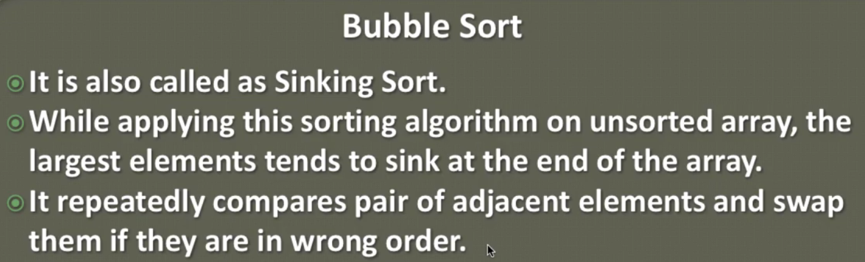

|  |  |
| --- | --- |
|  |  |
|  |  |
|  |  |
|  |  |

Let’s say we have given one un-sorted array. So to sort the given array in bubble sort we will have to perform the below steps

1. Perform the comparison of two adjacent array element like if ele1 > ele2 then perform swapping between them.
2. Since here the bigger number keeps shifting towards end of the array that is why it called sinking sort also. Once the biggest number like here first [6] gets settled in the right position then this element will take part in the swapping. And then complarision and swapping is performed among un-sorted elements of the array. This comparison and swapping keeps perform until all the elements get sorted.
3. As there is no any indication which can tell that now the elements got sorted, so to identify we keep tracking swapping, so when in any iteration or pass after comparison if swapping of the element does not happens at all in entire iteration or pass then it indicates that now the element got sorted.

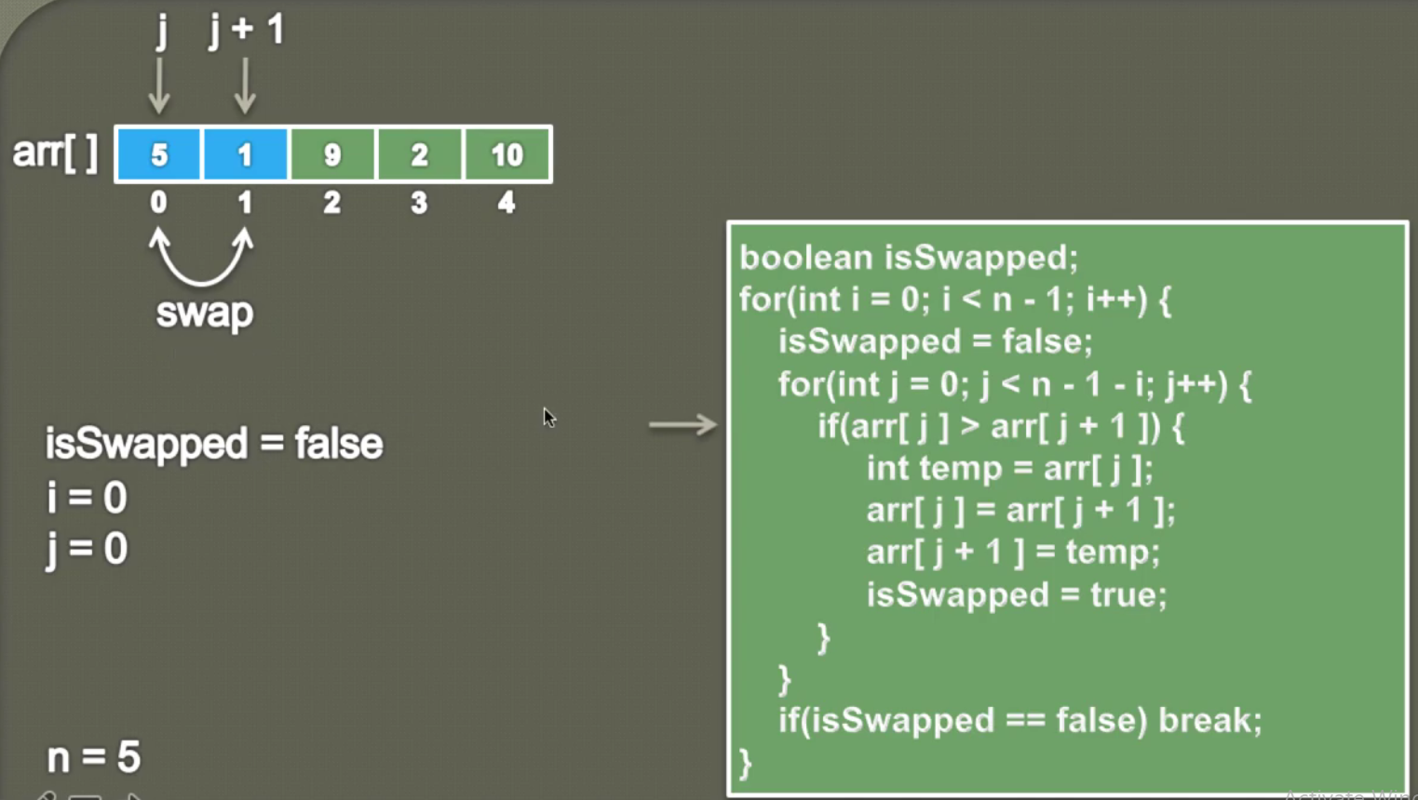

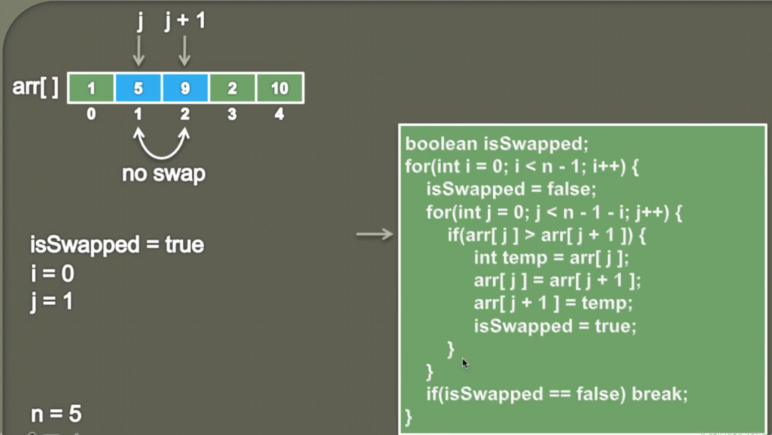

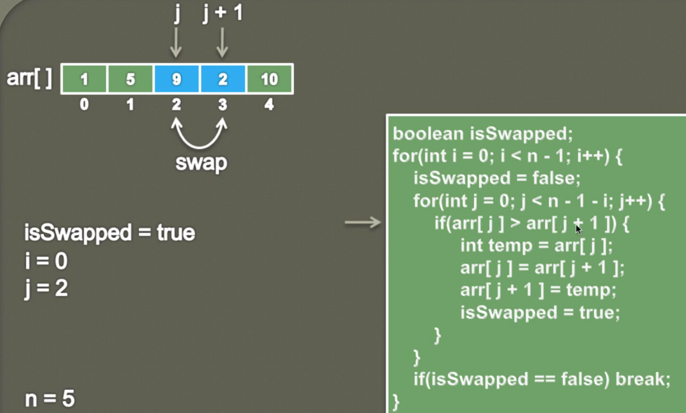

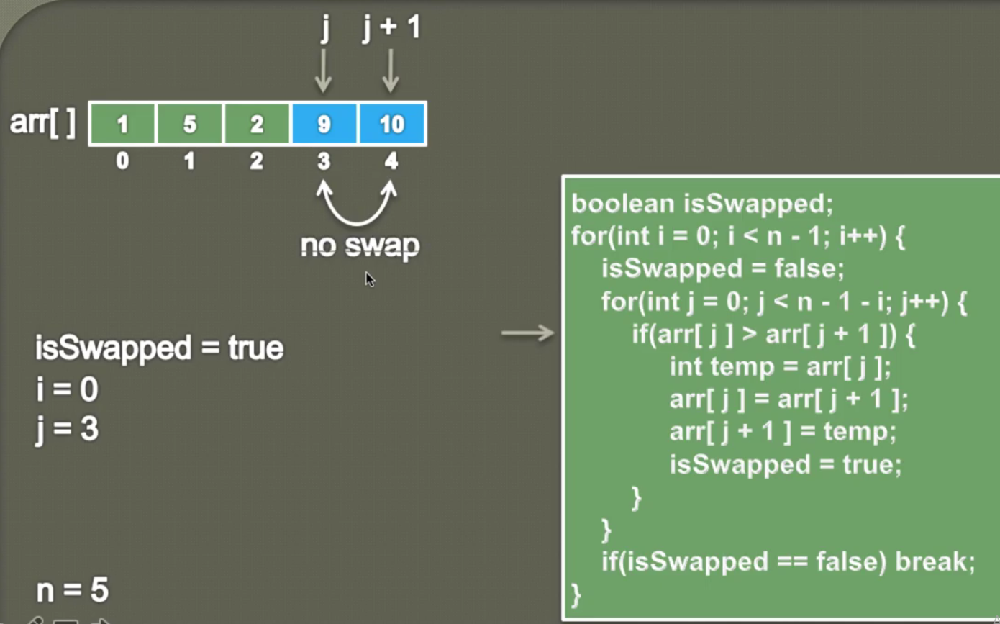So in the first iteration or pass the largest element 10 got settled, so now follow the same step for in the second pass and so on.

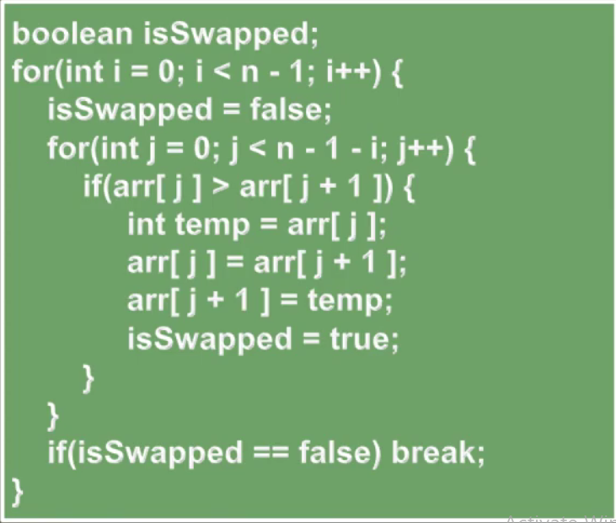

1. Here we have used two for loop, the outer for loop is for tracking swapping is happened or not in this iteration
2. The inner loop is used for comparison of two adjacent elements and performs swap if first element is greater than second and we are making isSwapped = true if swap performs in the particular iteration or pass
3. As we can see that in the in the outer loop the traverse is done i< n-1 because in each iteration one number it getting correct position so if there is 5 number then in the four iteration only all the number will be sorted because the last number would have been already sorted that is why we iterate the outer four loop (n-1) times
4. The inner loop is controlled by outer loop (i) that is why in the inner loop because once the largest number is settled in the right position then we don’t include that number in the second iteration for comparison and swapping and that is why in the inner loop traverse is done till (j < n -1-i)
5. If any swapping is performed in the particular iteration or pass then isSwapped =true
6. Once the inner loop compete its iteration then in the outer loop we keep check if (isSwapped ==false) and if the condition found correct then it means in the current iteration or pass swap does not perform at all and now all the element got sorted and now break the outer loop.

|  |
| --- |
| **package** com.data.structure.arrays;  **public** **class** K_BubbleSort_10 {  // PrintArray Method  // Method to print array  **public** **static** **void** printArray(**int**[] array) {  **for**(**int** i=0;i< array.length; i++) {  System.***out***.print(array[i] + " ");  }  }  // Method to sort array element  **public** **void** sort(**int**[] array) {  // Create one boolean to track swapping during the iteration  **boolean** isSwapped;  // Create an outer loop for controlling inner loop where comparison and performance will be performed and also track for swapping  // Here traverse will happen one less than size of array because for last element of array no need to perform and comparison or swapping because this last element will be sorted already  **for**(**int** i=0; i<array.length-1; i++) {  isSwapped = **false**;  // Create inner for loop for comparison and swapping operation and tracking swapping operation as true if swap happened  **for**(**int** j=0; j< array.length-1-i; j++) {  // Here we have used i so that if any element got settled in its position then will not be included in the next iteration Steps to perform comparison and swapping  **if**(array[j] > array[j+1]) {  **int** temp = array[j];  array[j]= array[j+1];  array[j+1]= temp;  isSwapped = **true**;  }  }  **if**(isSwapped==**false**)  **break**;  }  }  // main method  **public** **static** **void** main(String[] args) {    K_BubbleSort_10 bubble= **new** K_BubbleSort_10();  **int**[] array = **new** **int**[] {10,15,12,24,1,2,3,4,5,6,7,8};  *printArray*(array);  System.***out***.println();  bubble.sort(array);  System.***out***.println("After Sorting");  *printArray*(array);  }  } |
| **Output:**  10 15 12 24 1 2 3 4 5 6 7 8  After Sorting  1 2 3 4 5 6 7 8 10 12 15 24 |
| **Sort in Decreasing order: Only one change in the sort method:**  **public** **void** sort(**int**[] array) {  // Create one boolean to track swapping during the iteration  **boolean** isSwapped;  // Create an outer loop for controlling inner loop where comparison and performance will be performed and also track for swapping  // Here traverse will happen one less than size of array because for last element of array no need to perform  // and comparison or swapping because this last element will be sorted already  **for**(**int** i=0; i<array.length-1; i++) {  isSwapped = **false**;  // Create inner for loop for comparison and swapping operation and tracking swapping operation as true if swap happened  **for**(**int** j=0; j< array.length-1-i; j++) { // Here we have used i so that if any element got setteled in its positon then will not be incuded in the next iteration  // Steps to perform comparison and swapping  **if**(array[j] < array[j+1]) {  **int** temp = array[j];  array[j]= array[j+1];  array[j+1]= temp;  isSwapped = **true**;  }  }  **if**(isSwapped==**false**)  **break**;  }  } |
| 10 15 12 24 1 2 3 4 5 6 7 8  After Sorting  24 15 12 10 8 7 6 5 4 3 2 1 |

**121-Animation - Insertion Sort in Java - Part 1 _ Sorting Algorithms**



**Analogy**: So generally during the card play few cards we keep in our hand and usually we keep these cards in proper order and to keep them in proper order we use insertion sort algorithm.

So let’s say we have bunch of card, and generally when we take first card then we just keep in our hand because we have take first card and it would be sorted already because there is card so far to compare. And from second card onwards we start comparison with the card kept in our hand and based on comparison we keep this card either in left or right of the card of our hand. The bunches of card which are lying on the table are in unsorted form and the cards which are now in our hand are kept in sorted form. So now whenever we pink a new card from the table then usually compares it with all cards which are in our hand and based on comparison we keep this either first or last or in between based on comparison.

Similarly let’s say we have unsorted array, so using the insertion algorithm we divide the given array into two parts, sorted part and unsorted part.

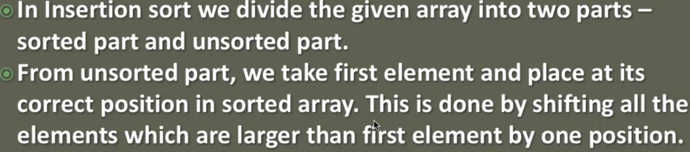

Let’s say we are sorting the array in ascending order, so the first element that we pick from unsorted part, we simply keep checking that element from each element available in the sorted part and all the element which are larger element, we simply shift them by one position and as soon as we encounter the element which is smaller than the first element we simply store that element just after that.

And its repeated till unsorted array is not empty.

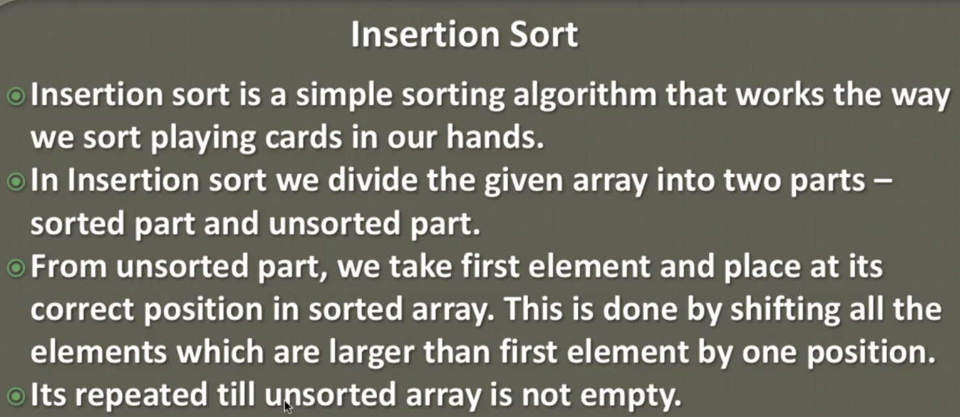

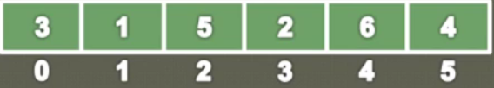

Let’s say we have sort the above array in ascending order, then follow the below steps.

1. We simply pick the first element from the array, as this the first element, so we don’t have any other element to be compared so this first element always considered as sorted. So basically this algorithm starts from the second element, because the first element is already sorted. So as we discussed earlier this array will be divided into two parts. 1- Sorted part 2- un-sorted part.

|  |  |
| --- | --- |
|  | So here the element to left (3) is already sorted and elements to the right are unsorted, so now from the unsorted part, we will pick the first element (1) and store this variable into temporary variable like [temp =1]. So as soon as we store this element into temp variable, then it means we are creating a vacant space here i.e. this part is empty. Now let’s compare them temp element with the sorted part element. Since we are sorting this array in ascending order so will compare whether 1 is less than 3 or not, so here 1 is less than 3 so 1 should come before 3 and before 3 there is no space, so we simply shift this 3 one position back to the empty place. And further check, is there any other element in the sorted array part to be compared with 1, so here we don’t have any other element, so we simply place one at its correct position. |
|  | After placing 1 at its correct position we will get two element in the sorted part.  Now again we pick the first element from unsorted part and store it into temp variable so that we could create an empty space to get shifted bigger element at this place if required.  Now let’s compare 5 with all the element of the sorted part, so we found that 5 is greater than 3 and it should come after 3 only , so in this case there is no shift because the element in the sorted array is already small from the element which we pick from un-sorted part and there will no further comparison with the sorted part element because 5 is already greater than 3. |
|  | Now again we will pick the first element 2 from unsorted part and store it into temp variable and then start comparing this element with elements available in the sorted part. Here we found that 2 is less than 5 so 5 will shift at the empty place, Now further comparison will happen with the remaining element of the sorted array because until comparison happen we cannot say which element is grater or smaller. So here first 5 will shift and then 3 will shift and when 2 will be compared with 1 then 2 will be placed after 2 because 1 is smaller than2 |

We keeps follow the above steps until all the unsorted parts gets empty and we get a sorted array .

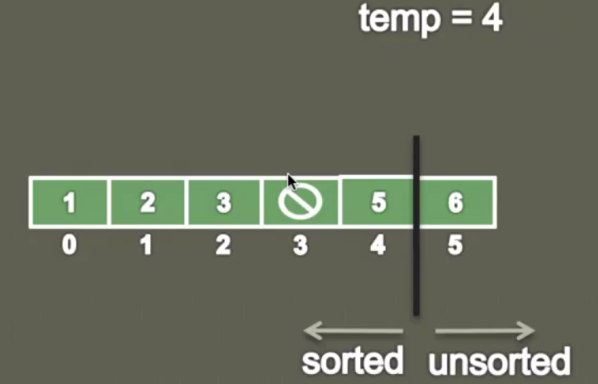

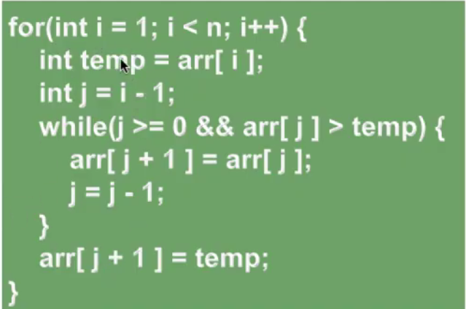

Use the above algo to sort the element in ascending order.

1. Let’s start traverse of the array element from the i=1, because as discussed the first element is considered as already sorted and put into sorted part of the array, that is why we start traversal from i=1 i.e. from second element from unsorted part of the array.
2. Now each element will be picked one by one from unsorted array in the for loop and will be stored into temp variable so that there could create one empty space to shift greater element if found.
3. Now create one variable j= i-1; just to traverse in the sorted part just going one index back, that is why here we have kept j = i-1; [ e.g. if i= 1 then j = 0 , if i = 2 then j = 2-1= 1 and so on]
4. Now in the while loop we will check until j >= 0 && Element at J’th position is > than temp element then =>
5. Then shift the element at j’th position to the (j+1)’th position. { arr[j+1] = arr[j] }
6. Now decrease j by one [j = j - 1] so that we can compare the temp element with other element available in the sorted part.
7. Now put the temp variable in the sorted part in the correct position (arr[ j+ 1] = temp)

**Note: So basically we divide the array into sorted and unsorted part and create two pointers i and j, i will traverse in unsorted part and j will traverse in sorted part of the array. And j will be controlled by pointer i.**

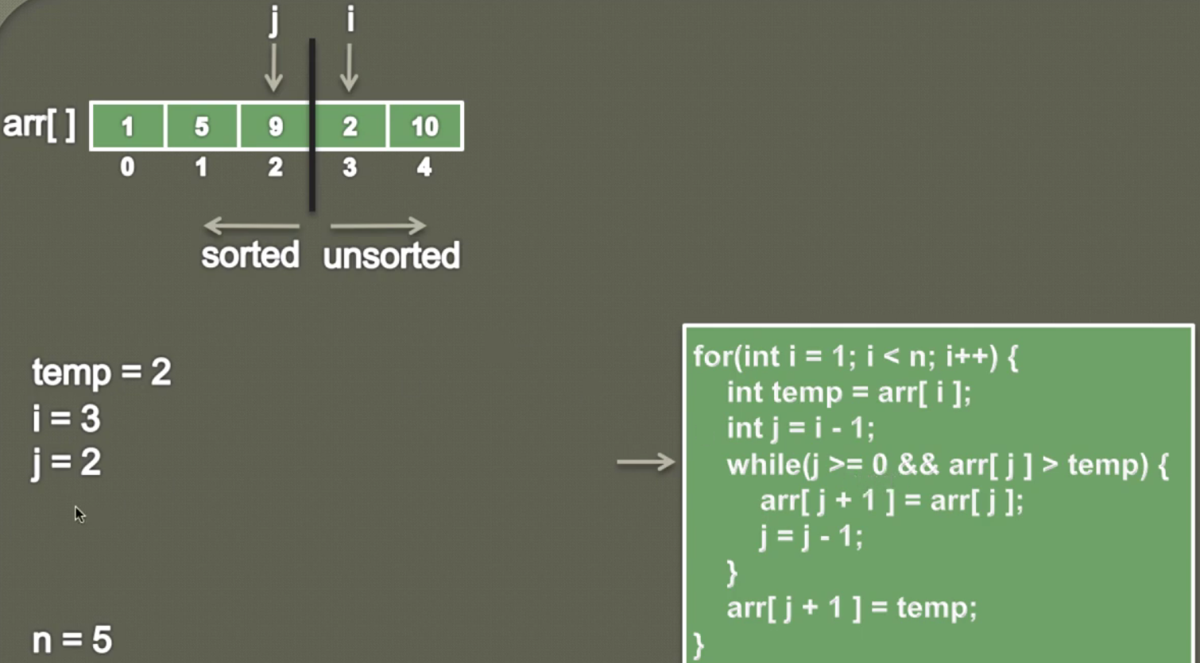

For example here i = 3(unsorted part position) then j will (i-1= 2) sorted part position.

* Now j (2) > = 0 && arr[2] i.e. 9 > than temp(2): while condition comes out true
* So shift arr[j] i.e. arr[2] i.e. 9 to the position (j+1) i.e. (2+1=3) I.e. 🡺 arr[j+1] = arr[j]
* Decrease by one to compare temp value with other element in the sorted part of the array.
* Finally after comparison is done place temp element in the correct arr [j + 1] place.

Program:

|  |
| --- |
| **package** com.data.structure.arrays;  **public** **class** L_InsertionSort_11 {  // Method to print array  **public** **static** **void** printArray(**int**[] array) {  **for**(**int** i=0;i< array.length; i++) {  System.***out***.print(array[i] + " ");  }  }  // Insertion sort method  **public** **void** insertionSort(**int**[] array) {  **for**(**int** i=1; i<array.length; i++) {// i will traverse in unsorted part and Start with 1 because first  element is already considered as sorted  **int** temp = array[i]; // pick one element from unsorted part and and keep into temp variable  **int** j = i-1; // j will be traverse in sorted part  **while**(j >=0 && array[j] > temp) { // Creating boundary on sorted part because the min index of  any array is 0 or greater and checking element at j'th  position is greater than temp element    array[j+1] = array[j]; // shift element at j'th position to one position ahead at empty place  j = j -1; // decrease j by 1 so that remaining element at sorted part could be compared with temp  element  }  array[j+1] = temp; // place the temp element at the correct place after comparison done with all  element available in sorted part  }  }  **public** **static** **void** main(String[] args) {    L_InsertionSort_11 sort = **new** L_InsertionSort_11();  **int**[] array = **new** **int**[] {10,15,12,24,1,2,3,4,5,6,7,8};  *printArray*(array);  System.***out***.println();    sort.insertionSort(array);  System.***out***.println("After Sorting");  *printArray*(array);  }  } |
| **Output:**  10 15 12 24 1 2 3 4 5 6 7 8  After Sorting  1 2 3 4 5 6 7 8 10 12 15 24 |

To sort the array in descending order we will have make one change:

**while** (j >=0 && array[j] < temp) {

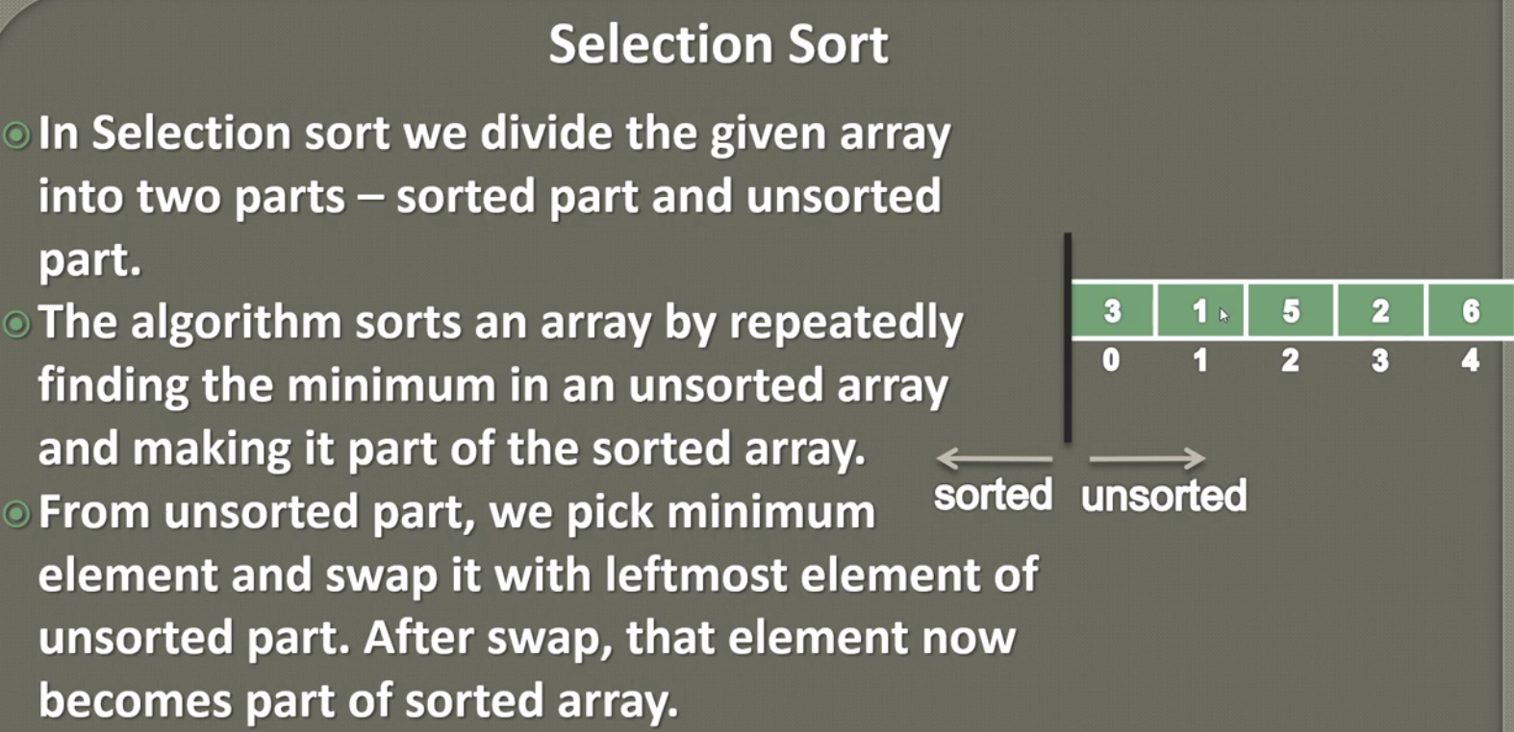

So as here the minimum element in unsorted part is 1, so let’s swap 1 with leftmost element 3 so if rearrange the above mentioned array then it will look like as given below.

|  |  |
| --- | --- |
|  | Repeat the above steps until unsorted array is empty. |

**Explanation**

|  |  |
| --- | --- |
|  | The array length = 6  In the first pass let’s say the first element of unsorted part is (min =3). Now when compare it with next element then 3 is not less than 1. So now 1 will become min element.  So now min =1;  Now this min will be compared with the rest of the element of the array.  Finally 1 is the minimum element of the array.  Now swap this min element 1 with the leftmost element[3] of the array |
|  | As in the first pass we have got minimum element of the array so it will considered as sorted part.  Now in the next swap the first element of unsorted part is 3, so let’s say min=3 and again let’s compare it with the 5 so 5 is not less than 3.  Now min=3 will be compared with 2 and found 2 is less than 3. So now min will 2 i.e. min=2.  Now this min=2 will be compared with rest of element. And finally we found 2 is minimum element in the unsorted part.  Now let’s swap this min=2 with the leftmost element 3 |
| Repeat the above step for 3rd | Repeat the above step for 4th |
|  |  |
| Repeat the above step for 5th |  |
|  | Finally we have left with one element 6 and for that we don’t need to perform the abvoe step because is already correct postion.  So we can see that we have to follow the above steps for n-1 times when n is the length of array. |

**So in sort:**

1. We divide the array into two part- sorted and unsorted and at the begining all the element will come in unsorted
2. Apply the selection sort in different passes (iteration), in each iteration we find the minimum element from the unsorted part and simply swap it with the leftmost element of the unsorted part.
3. After this swap the minimum element that just found will become the part of sorted array
4. The above steps will be repeated until all element of unsorted part becomes sorted part.

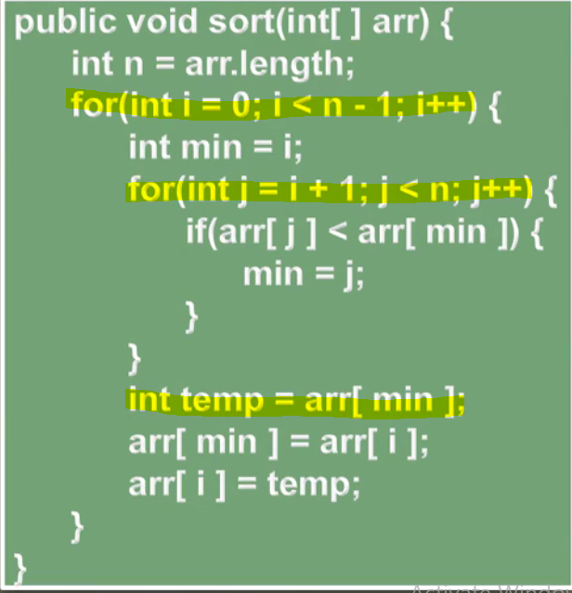

**Explanation:**

1. The outer for loop will iterate till (n-1) times because the last element will automatically be sorted and no need to perform further finding search and swap operation
2. Inside the outer loop let’s say the first element at 0 index is min element
3. Now considering element at min (0) as minimum, let’s compare this value with other element in the unsorted part and if found any element which is less than the value at min (0) then assign (update) this found min element index in the min variable. So to find minimal value we will create one for loop which will be initialized with (i+1) because we have start comparison with the next element and keep continue for entire unsorted element.
4. Once we get the min element then in the outer for loop let’s perform swapping with the leftmost element of the unsorted part.

In sort:

1. Two for loop being used
2. The inner loop is being used to find the minimum element from the unsorted part.
3. The outer part is being used to swap the minimum element with the leftmost element of the unsorted part.

|  |
| --- |
| **package** com.data.structure.arrays;  **public** **class** M_SelectionSort_12 {  // Method to print array  **public** **static** **void** printArray(**int**[] array) {  **for**(**int** i=0;i< array.length; i++) {  System.***out***.print(array[i] + " ");  }  }  **public** **void** sort(**int**[] array) {  **for**(**int** i= 0; i < array.length-1; i++) {  **int** min =i;  **for**(**int** j=i+1; j <array.length; j++) {  **if**(array[j] < array[min]) {  min =j;  }  }  **int** temp = array[min];  array[min] = array[i];  array[i] = temp;  }  }    **public** **static** **void** main(String[] args) {    M_SelectionSort_12 selection = **new** M_SelectionSort_12();  **int**[] array= **new** **int**[] {10,15,12,24,1,2,3,4,5,6,7,8};  *printArray*(array);  System.***out***.println();    selection.sort(array);  System.***out***.println();  *printArray*(array);  }  } |
| 10 15 12 24 1 2 3 4 5 6 7 8  After sort  1 2 3 4 5 6 7 8 10 12 15 24 |

**Difference between Bubble Vs Insertion Vs Selection sorts:**

|  |  |  |
| --- | --- | --- |
| **Bubble sort** | **Insertion sort** | **Selection sort** |
|  |  |  |